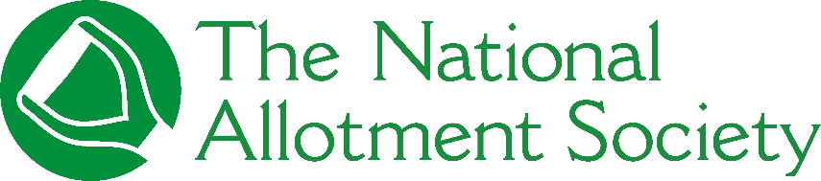
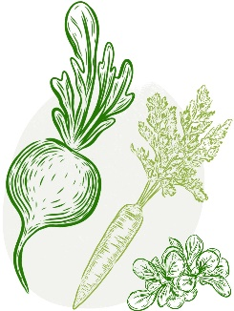
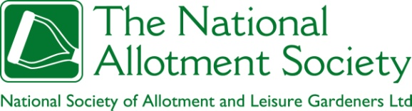
FOR IMMEDIATE RELEASE
National Allotment Society announces ‘Grow to Learn’ theme for National Allotments Week 2026

The National Allotment Society (NAS) has today announced the theme for National Allotments Week 2026, taking place from 10–16 August 2026. The new theme, Grow to Learn – Lifelong lessons from the allotment, will celebrate the educational, personal development, and well-being benefits of allotment gardening for people of all ages.
The theme highlights how allotments function as living classrooms, where learning happens through hands-on experience, shared knowledge, and connection with the natural world. Alongside practical growing skills, allotment gardening nurtures wider life skills including patience, resilience, curiosity, problem-solving, and teamwork — and, of course, physical wellbeing and food security.
Through time spent on the plot, individuals learn to adapt to challenges, understand seasonal change, and develop confidence and wellbeing alongside their crops. These informal learning experiences often span generations, making allotments unique spaces for lifelong learning, community connection, and personal growth.
By focusing on Grow to Learn, the National Allotment Society aims to reframe allotments not just as places to grow food, but as dynamic learning environments that support personal growth, mental and physical wellbeing, and food security.
National Allotments Week 2026 will feature a national digital campaign sharing stories and reflections from allotment holders and ambassadors, highlighting the many ways allotments act as living classrooms and places of continual learning.
Further details about National Allotments Week 2026 activities, resources, and opportunities to get involved will be announced in due course.
National Allotments Week takes place from 10–16 August 2026.
Ends
The National Allotment Society (NAS) is the UK’s leading organisation representing more allotment holders and leisure gardeners. NAS provides advice, guidance, and advocacy to support people in growing their own food, improving their well-being, and connecting with their communities.
With a nationwide network of 130,000 members, volunteers, and ambassadors, NAS works to make allotments engaging, inclusive, and rewarding — supporting physical and mental well-being, social connection, and environmental awareness through the simple act of growing.
For more information, visit www.thenas.org.uk

Charlotte Watts
Press Officer, National Allotment Society
Marketing@thenas.org.uk

